**Project 2 - Part 2 - Data Report**

**Star of Providence/Monolith**

**Nasif Ahmed**

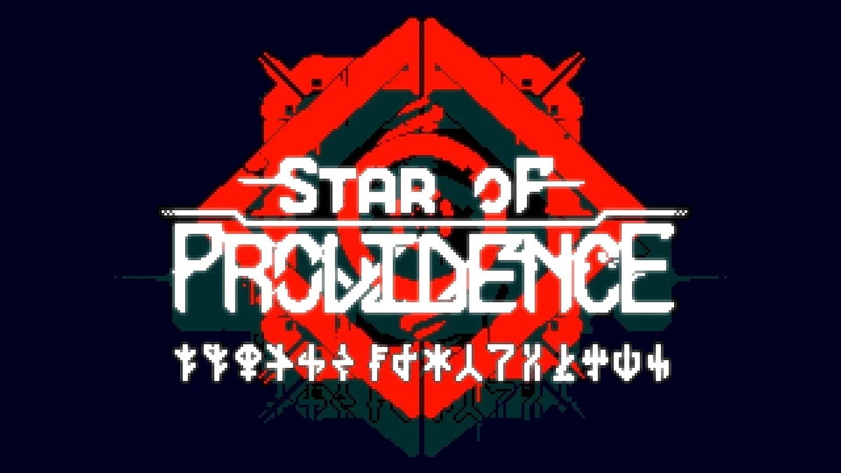

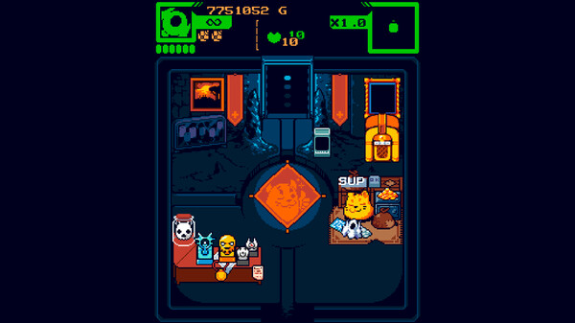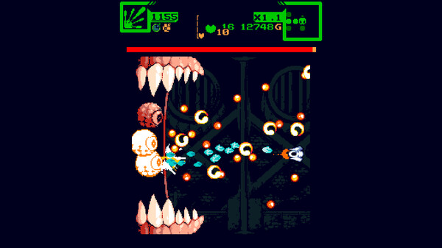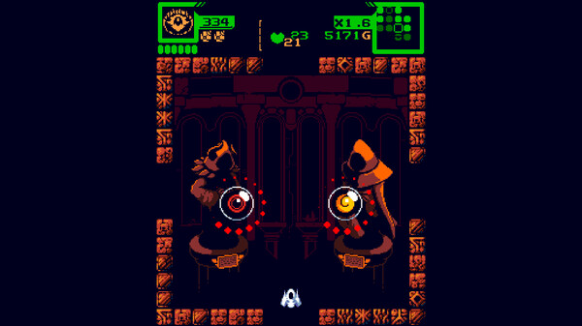

INTRODUCTION

*Star of Providence* (formerly titled “Monolith”, and will be henceforth referred to as “Monolith”) is a roguelite top-down shooter in which you control a little spaceship entering the depths of an ominous facility. Guns blazing, you maneuver around swathes of enemy bullets whilst collecting loot and upgrades, all while keeping an eye on your ammo count.



It’s pretty awesome. You have to think resourcefully--every bullet counts, so you can’t just spray and pray. Simultaneously, you have to evade the equivalent of a firing squad (the preview above is only the second level) and be aware of the terrain and environmental hazards around you. Healing items are hard to come by. Needless to say, this game is *brutal*. Check it out if you’re cool.

Mechanics

We don’t have to dissect the entire game here, though I’d like to. For now, let’s just bring up mechanics as needed.

The player () has a slot to hold a weapon--these weapons come in all shapes and sizes, ranging from a shotgun, a laser, a drill, throwable sawblades, and more.

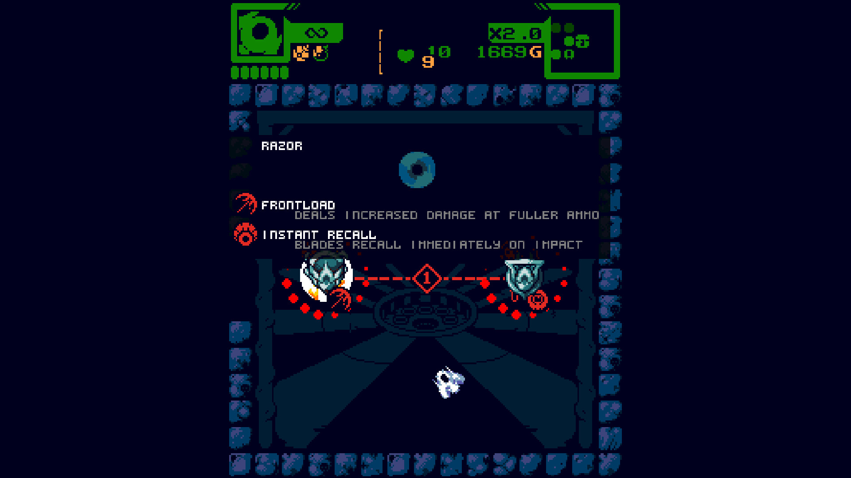

Pictured: A choice between two weapons (the insignia looking things with red circles around ‘em). Weapons come with modifiers that change how they behave.

These weapons *usually* come with an ammo count. They’re fully stocked on pickup. The weapon breaks once it hits 0 ammo. If you don’t have a weapon equipped, you use your built-in weapon, which is far weaker.



Default Weapon (Infinite Ammo)



“Charge” Weapon (Currently has 1155 Ammo)

When clearing a room, or opening a crate full of weapons, or however else, a weapon can spawn that might be “cursed”. These weapons, when picked up, will have infinite ammo, give the player 2 HP, and give a permanent 5% damage increase. As previously mentioned, health isn’t easy to come by, so this seems like a no-brainer.

However, there’s a reason it’s referred to as a *cursed* weapon. You can’t replace the weapon with another weapon while you have it, and infinite ammo means you’re stuck with it. Not forever, though--it randomly breaks after a random number of rooms. Oh, and you also have to deal with a debuff for the duration you have the weapon.

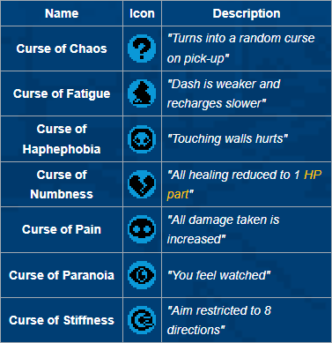

Table of curses that might come with weapons, taken from the [wiki](https://starofprovidence.wiki.gg/wiki/Weapons#Cursed_Weapons).

The player is met with a dilemma--pick up this weapon, which might provide a much needed boost in health and damage, but temporarily be unable to pick up a possibly better weapon that comes later (all while dealing with a curse)? (By the way, if you can’t pick up an item in a room, you can’t come back to it later. As soon as you leave the room, the item breaks, so you can’t just go back to a good weapon you found after your curse breaks. The weapon might ditch you right before a boss, and then you won’t have a proper weapon.)

DATA

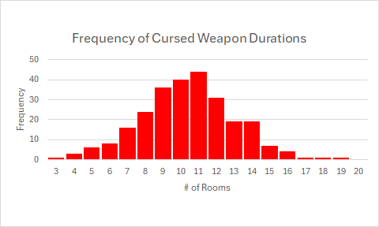

Courtesy of the *Monolith* community, they’ve given me a nice little .csv file of 261 cursed weapons’ durations (as well as their type, which we will bring up later). Meaning, they picked up 261 of these cursed weapons and measured how many rooms they lasted before they break. Here’s a relative frequency histogram of that data.

We can see that it has a bell curve to it, so that narrows down what distribution it falls under. It doesn’t have continuous values like normal distributions would, but it’s not representing a number of successes over a number of trials like a binomial distribution. Looking under the hood, we can see that it’s really more of a normal distribution.

The official wiki says the following:

“When a cursed weapon is equipped, the game rolls 5D20 (five 20-sided dice), then averages the result and rounds them to the nearest integer, the game using that integer as the number of rooms you must clear before the weapon breaks.”

So, upon further inspection, we can see that these are actually continuous values that’ve been rounded. If we were to measure the exact value in the code before being rounded, it would be a normal distribution. However, the duration can only be expressed in integers, hence the discrete values.

Measurements and Portions

| MEAN | 10.01795 |
| --- | --- |
| MEDIAN | 10 |
| MODE | 11 |
| VARIANCE | 7.041565 |
| STDV | 2.653595 |

Here’s some measurements made using Excel’s built-in functions. As you can see, mean, median, and mode are all expectedly at the center of the bell curve. Knowing how the duration is calculated (the average of 5 d20’s), there should be an average value of 10.5. We can see that our mean and median of the sample reads at 10. The mode, however, reads at 11. It seems that, overall, our sample is ever-so-slightly skewed to the left of the actual table, but by a negligible amount.

Looking at our variance and standard deviation, we can see how close the values are dispersed. 68% of the values are between 7.3-12.6, 95% of values range from 4.7-15.3, and 99% of the values range from 2-18.

We don’t have a measurement for when a weapon breaks on the very first room or when it lasts 20, but we know that they’re in that 1% of occurrences, since there’s a hard bound of 1 and 20. If we were to cheat and run the chance 5 d20’s average and round to 1 or 20, the actual chances are 0.0007% each! That would explain why there’s no measurements of it happening in our 261 measurements.

We’ll be measuring the chances that something happens by measuring the portion size of the graph that event takes up, assuming our sample is a reliable representation of the true behavior. Let’s group the measurements together--what’s the chance of a cursed weapon lasting at most 10 rooms? More than 10 rooms? (This is the same as asking, “What portion of the data lasts…?”)

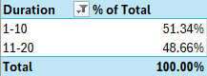

The results are roughly 50/50. (We know it would be *exactly* 50/50 because we know how the duration is calculated, but we’re going to follow the measurements.) This is… a little lame of a measurement, so let’s also see what the chance of getting at least 15 rooms out of a cursed weapon is.

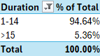

Quick aside: What’s a “run”? A run is one playthrough of the game, from start to finish (whether that is winning or death). Roguelikes are defined by a mechanic called “Permadeath”, where a player’s run is over as soon as they die once. You start over from the top. For a difficult game such as this one, you’d be dying *a lot*, so you’re going to be playing a lot of these “runs”.



Ringleader.

Sample Spaces

Let’s consider this: A player picks up 3 cursed weapons throughout their run. What’s the chance that at least 2 of those 3 lasts more than 10 rooms? For sake of simplicity for this question, let’s make the chance exactly 50/50. Let’s make a sample space S, where T represents a curse that lasts that duration:  
 *S = {TTT, TTF, TFT, FTT, TFF, FTF, FFT, FFF}*

We can see that there are 4 events out of 8 that fall under the condition. Under the assumption that it’s exactly 50/50, we can see that all of these events are equally likely, and can simply calculate the number of satisfying events by the total. The chance that at least 2 of 3 cursed weapons last more than 10 rooms is 50%.

Union/Intersection/Complement

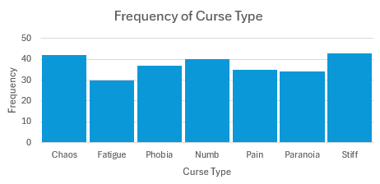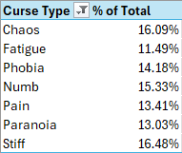

Here’s a frequency histogram of the type of curse a weapon will appear with, measured from those same 261 cases. We’ll talk about it more in combinations and others, but let’s show it here now.

A player clears a room and a cursed weapon spawns. What’s the chance that it has “Curse of Pain” and lasts for at least 15 rooms? We’ll use the measured data from the histogram for the curse chance.

(0.1341) * (0.0536) = 0.0072

In words, the chance of a cursed weapon that has “Curse of Pain” that lasts at least 15 rooms is a 0.72% chance.

What’s the chance of a weapon spawning with “Curse of Pain” *or* the curse lasting at least 15 rooms? We’ll use the measured data for the curse chance.

(0.1341) + (0.0536) - (0.0072) = 0.1805

Since this is a union of events that aren’t mutually exclusive, we have to subtract the chance of them both happening simultaneously. The chance would be roughly 18.05%.

The chance of *not* getting “Curse of Pain” or lasting at least 15 rooms is easy enough. Just do a quick inversion of the value above, and you’ll find it’s about 82%.

1 - 0.1805 = 0.8195

We can compile a table using these values.

|  | <=10 Rooms | >10 Rooms | Total |
| --- | --- | --- | --- |
| Curse of Pain | 6.88% | 6.52% | 13.41% |
| Other Curse | 44.45% | 42.13% | 86.59% |
| Total | 51.34% | 48.66% | 100% |

Using this table, we can answer: “What’s the chance of getting Pain for at most 10 rooms, or getting something else for more than 10 rooms?”

.0688 + .4213 = .4901



Oh look, a shop!

Combinations

Let’s say that there are 2 cursed weapons. As a reminder, a cursed weapon has one out of 7 possible curses. How many different arrangements of curses would there be?

7 * 7 = 49

Simply put, there would be 49 combinations. You multiply one weapon with the other.

Conditional Probability

Let’s look at this table again.

|  | <=10 Rooms | >10 Rooms | Total |
| --- | --- | --- | --- |
| Curse of Pain | 6.88% | 6.52% | 13.41% |
| Other Curse | 44.45% | 42.13% | 86.59% |
| Total | 51.34% | 48.66% | 100% |

The probability of a curse lasting longer than 10 rooms is 48.66%. The probability that the weapon spawns with the Curse of Pain is 13.41%. The chance of both happening simultaneously is 6.52%. Intuitively, we already know that the duration and type are independent, but let’s calculate conditional probability regardless.

P(A|B) = P(A n B)/P(B)

P(Pain | >10) = 0.0652/0.4866 = 0.1339 (rounding error)

The chance of a weapon spawning with the Curse of Pain given that the curse lasts longer than 10 rooms is roughly the same as the chance of a weapon spawning with the Curse of Pain. In other words, the two are independent.

Multiplicative and Additional Probability

What’s the chance of a weapon spawning with Curse of Pain, Numbness, or Stiffness? These are mutually exclusive things--a weapon can’t have more than one curse (fortunately), so we’ll simply add the chances:

.1341 + .1533 + .1648 = 0.4522

The chance of any of those 3 curses being the one that spawns would be about 45%.

What’s the chance of a weapon spawning with Curse of Haphephobia and a weapon spawning with Curse of Chaos? These are independent events, so we multiply the chances:

.1418 * .1609 = .0228

The chance of getting Haphephobia and Chaos is roughly 2.3%.



Ordinator.

Bayes’ Rule

Someone mods their game so that when it launches, it either has the normal chances for curses, or changes the chances so that Curse of Pain has a 50% chance instead of the measured 13.41%. They boot the game and get a cursed weapon with Curse of Pain on it. What’s the chance that they’re on the modified version? Let’s make a tree:

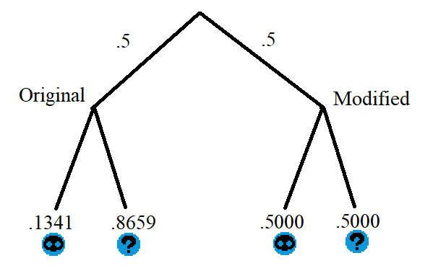

Now, let’s divide the chance of Pain on the modded game by the total chances for Pain.

.5/(.1341 + .5) = 0.7885

There’d be a 79% chance that the game was on the modified version.

Random Variables

The random variable, Y, would be the duration of cursed weapons. It would simply be represented by the frequency histogram. It has been modified to show a percentage instead.

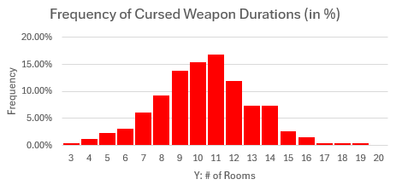

Expected Value

We’re going to use this formula:

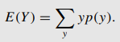

Multiplying each value by their corresponding probability and summing it all up, we get: 10.39464. Interestingly enough, this is slightly different than the previously calculated mean from a previous section. However, the closeness means that this discrepancy likely has to do with a rounding error.



Fish.

Binomial Distribution

We know that the chance of a cursed weapon lasting at least 15 rooms is 5.36%. Let’s assume you play a run where you somehow encountered and equipped 10 cursed weapons (they’re not very common, but that’s besides the point). Out of those 10, what’s the chance that 2 of those last longer than 15 rooms? We’ll fill out the formula for binomial distribution:

10C2 * (0.0536)2 * (.9464)8 = 0.0832

The chance that exactly 2 of those 10 cursed weapons last longer than 15 rooms is about 8.3%.



Ice Wyrm.

Geometric Distribution

Now let’s consider a similar problem. Using the graph above, we can see that the chance of getting a cursed weapon that lasts exactly 10 rooms is 15.33%. Let’s say a player gets 3 cursed weapons within a run (a much more reasonable amount). What’s the chance that the third weapon lasts exactly 10 rooms? We’ll fill out the geometric distribution formula:

.1533 * (1 - .1533)2 = 0.1099

The chance that the only the third weapon out of 3 cursed weapons lasts exactly 10 rooms is about 11%.



Nightmare.

Negative Binomial Distribution

Let’s step away from duration for a bit, and go back to curse types. We can calculate the probability of some number of successes occurring after a number of failures. Let’s consider a player who’s collected 5 curse weapons. What’s the chance that the fifth curse is the third Stiffness curse?

5-1C3-1 * .16483 * (.8352)5-3 = 0.0187

We find that the chance would be roughly 1.9%.

Hypergeometric Distribution

This distribution involves measuring a number of successful draws out of a number of draws from a finite population without replacement. However, this doesn’t really fit neatly into the current mechanics (or any mechanics from *Monolith* that I can think of). Let’s make up a hypothetical scenario of a shop, however. This shop, a gachapon machine, holds “keywords”. Keywords are modifiers that come with/can be applied to weapons that modify their behavior (“Curse of Pain” and the others are technically keywords). There’s 60 keywords in the game, excluding the 7 curses.

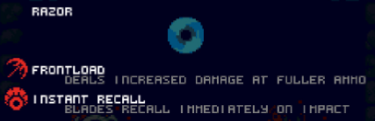

Let’s say this gachapon machine holds all 67 keywords. You only have enough money to pull 10 keywords from said shop. What’re the chances that from those 10 pulls, the player pulls all 7 curses?

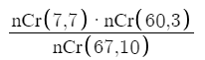= 0.000000001379

The chance would be very low, evidently. The chance of pulling all curses from this machine would be a little over 1 in 100 million.

Poisson Distribution

There is nothing in the game that operates based off of actual time, so no one’s ever measured anything in relation to it. As of writing this, neither the curse duration or the type data can be used. So, I’ve taken it upon myself to measure some data! I booted up the game and measured how long a room takes to beat.



<https://www.youtube.com/watch?v=JIiRy1Mjmso>

What a run! Let’s write down the numbers:

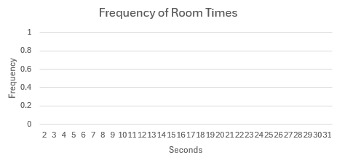

Wow!

Jokes aside, I played a full run and measured the time it took each room to beat, from start to finish (by winning, not dying!). Not a small dataset by any means--the run had 161 rooms, so that’s 161 entries.

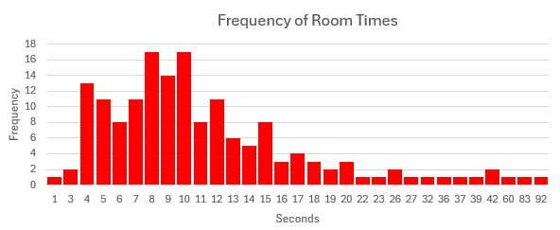

How slopey!

Here’s the actual run, if you’d like to watch.



<https://www.youtube.com/watch?v=yhyB6AObebs>

Trimming the last 3 values (60, 83, and 92 seconds) as they’re outliers (boss fights), I’ve measured that the mean value for how long a room takes for me to beat is 11.05 seconds, which we’ll round down to 11.

Let’s assume that I clear a single room every 11 seconds on average and that the Poisson Distribution applies. What’s the probability that I clear at least 4 rooms in 22 seconds?

Our lambda would be 2, being a simple multiplication to account for the rate being 22 seconds instead of 11. Next, we need to find the complement of the chances it takes for 0, 1, 2, and 3 rooms to be completed in that time.

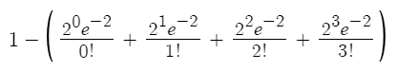

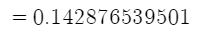

The chance I’ve cleared at least 4 rooms within the span of 22 seconds is about 14.3%. Not quite up to par with my friend who speedruns the game (and verifies runs on speedrun.com, since he’s literally one of the best players), but just you all wait...

Tchebysheff’s Theorem

Let’s look at the room times again. It has a standard deviation of 7.33, but the empirical rule won’t help as it’s positively skewed. Let’s say we don’t know the exact data and we want to know something about the chance the room time is between 0 and 25.66 seconds (2 standard deviations away from the mean)? Using Tchebysheff’s Theorem, we can see:

1 - (1/22) = .75

We can be certain that there’s *at least* a 75% chance that the room time falls between those bounds.

Distribution and Density Functions

We can find the distribution function of the room times, *F(y)*, by summing up the percentages of each measured value. The density function would simply be the histogram of the data, however.

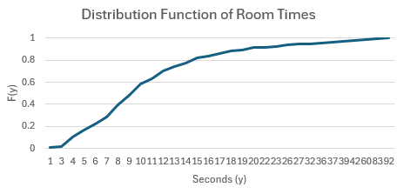

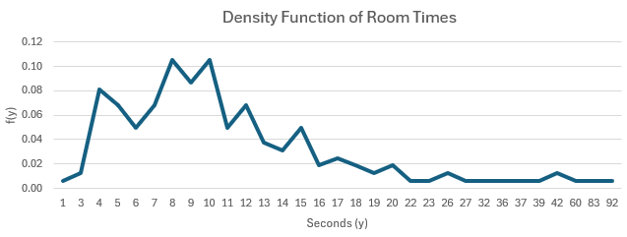



Devourer.

Uniform Distribution

The closest thing we have to a uniform distribution is our data for curse types, which would be discrete, not continuous. Plus, these values are measurements of quality, not quantity. Let’s ignore that and treat it as though it were continuous, and that the values were mapped to numbers.



The expected value here, though it would be incorrect, would be Curse of Numbness. You’d simply find the midpoint between Chaos and Stiff.

Exponential Distribution

Let’s assume the time between rooms being completed follows an exponential distribution (even though it resembles more of a Gamma Distribution). With a mean of 11 seconds, what’s the probability that a room exceeds 30 seconds? We can fill out the formula for exponential distribution.

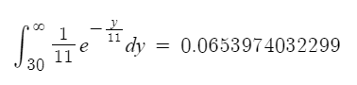

Bivariate Distribution

The bivariate probability for discrete random variables Y1 and Y2 can be represented as p(y1, y2) = P(Y1 = y1, Y2 = y2). Simply put, this is a probability of a union, which we already went over previously. Let’s make a table using the Excel data out of the curse durations (1-20) and curse types (1-7).

|  | 1 | 2 | 3 | 4 | 5 | 6 | 7 |
| --- | --- | --- | --- | --- | --- | --- | --- |
| 1 |  |  |  |  |  |  |  |
| 2 |  |  |  |  |  |  |  |
| 3 |  |  |  |  |  |  | 1 |
| 4 | 1 |  |  |  |  |  | 2 |
| 5 | 1 | 1 | 1 | 1 | 1 | 1 |  |
| 6 | 2 | 1 | 1 | 2 | 1 |  | 1 |
| 7 | 5 | 1 | 2 | 1 | 2 | 3 | 2 |
| 8 | 3 | 3 | 7 | 1 | 4 | 3 | 3 |
| 9 | 6 | 6 | 6 | 6 | 2 | 2 | 8 |
| 10 | 8 | 4 | 2 | 8 | 5 | 5 | 8 |
| 11 | 4 | 5 | 7 | 10 | 5 | 7 | 6 |
| 12 | 5 | 3 | 5 | 5 | 4 | 4 | 5 |
| 13 | 3 | 2 | 4 | 4 | 4 | 1 | 1 |
| 14 | 2 | 4 |  | 2 | 3 | 5 | 3 |
| 15 |  |  | 2 |  | 2 | 2 | 1 |
| 16 | 1 |  | 1 |  | 1 | 1 |  |
| 17 |  | 1 |  |  |  |  |  |
| 18 |  |  |  |  |  |  | 1 |
| 19 |  |  |  |  | 1 |  |  |
| 20 |  |  |  |  |  |  |  |

Whew… had to do that manually…

Now we can ask questions. The chance of getting the 4th curse for 11 rooms is 10/261. The chance of getting any of the first 3 curses for at most 5 rooms is 4/261.

Marginal Probability

Fortunately, we can just reverse the work we did for Bivariate Distribution to get the marginal probability function.

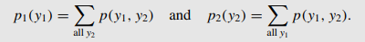

Let’s say p1(y1) is the marginal probability function of curse durations. We total the numbers for each duration across the different types of curses, getting:

| 3 | 1 |
| --- | --- |
| 4 | 3 |
| 5 | 6 |
| 6 | 8 |
| 7 | 16 |
| 8 | 24 |
| 9 | 36 |
| 10 | 40 |
| 11 | 44 |
| 12 | 31 |
| 13 | 19 |
| 14 | 19 |
| 15 | 7 |
| 16 | 4 |
| 17 | 1 |
| 18 | 1 |
| 19 | 1 |

With this, we can answer some simple marginal probability questions. p1(10) would be 40/261, and p1(15) would be 7/261.

CONCLUSION

Analysing *Star of Providence*’s mechanisms like this is… admittedly pretty useless for many of the things we looked at. The only things that really matter in terms of gameplay is the curse durations, since it’s evident that curse types are equiprobable. For bosses, you want to try to have the cursed weapon at most 10 rooms prior to fighting the boss to maximize the chances you’ll have infinite ammo for the fight. If you have infinite ammo, you won’t have to worry about accuracy and can just focus on dodging bullets. As for room times, that can be useful to see how speedily a player completes rooms. A speedrunner would have a much lower mean for the room times, and measuring the data for that was a fun statistical view on how I play the game.

Regardless of whether or not we’ve actually done anything of value, we’ve looked at the game in a variety of different statistical perspectives. Maybe you should look at it in a gameplay perspective? Seriously, check it out (only if you’re cool).



RESOURCES

Images and GIFs:

[The Monolith Wiki](https://starofprovidence.wiki.gg/wiki/Bosses)

[Monolith’s Steam Page](https://store.steampowered.com/app/603960/Star_of_Providence/)

Curse Duration Info:

[The Monolith Wiki](https://starofprovidence.wiki.gg/wiki/Weapons#Cursed_Weapons)